**Name: Nafinur Leo**

**Id: 20-42195-1**

**Course Name: Data Communication**

**Section: D**

**Lab Report Number: 01**

**Semester: 2021-2022 Fall**

**Submission Date: 27-09-2021**

**Lab Performance Task**

‘

ID = AB-CDEFG-H

Here, my id is: 20-42195-1

A = 2

B = 0

C = 4

D = 2

E = 1

F = 9

G = 5

H = 1

Generate two sinusoids with different amplitudes, frequencies, and phases:

x1(t) = K1*cos(2π(E+F+5)t + J1)

x2(t) = K2*cos(2π(C+D+5)t + J2)

K1 = A+B = 2 + 0 = 2

K2 = G+H+2 = 5 + 1 + 2 = 8

J1 = D+G+20 = 2 + 5 + 20 = 27º = 27*pi/180

J2 = 30º = 30*pi/180

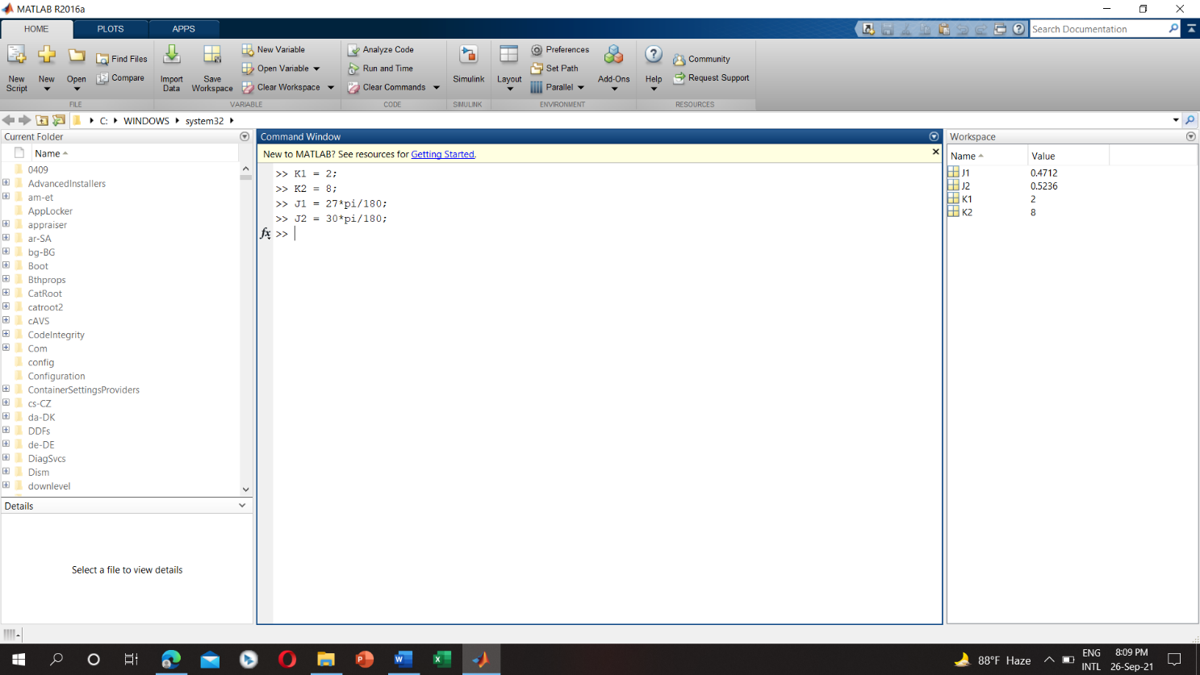

a) K1 = 2

K2 = 8

J1 = 27*pi/180

J2 = 30*pi/180

C = 4

D = 2

E = 1

F = 9

t1 = 0:0.0001:0.23

x1(t1) = K1*cos(2π(E+F+5)t + J1) = 2*cos(2*pi*(15)*t1+27*pi/180)

Code:

t1 = 0:0.0001:0.23;

x1 = 2*cos(2*pi*(15)*t1+27*pi/180);

figure;

plot(t1,x1);

xlabel('(time)');

ylabel('(amplitude)');

title('Sinusoidal Signal');

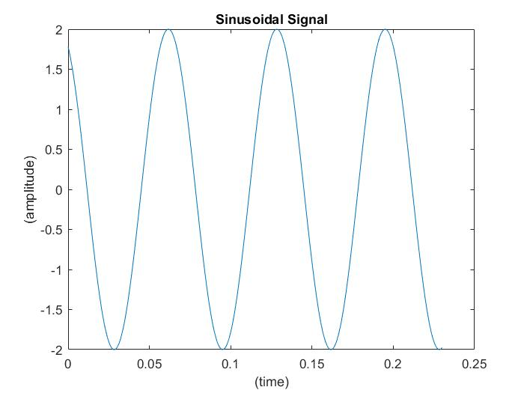

t2 = 0:0.0001:0.31

x2(t) = K2*cos(2π(C+D+5)t2 + J2) = 8*cos(2*pi*(11)*t2+30*pi/180)

Code:

t2 = 0:0.0001:0.31;

x2 = 8*cos(2*pi*(11)*t2+30*pi/180);

figure;

plot(t2,x2);

xlabel('(time)');

ylabel('(amplitude)');

title('Sinusoidal Signal');

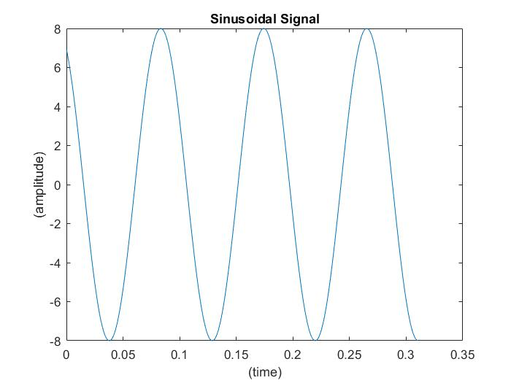

b) x3(t) = x1(t) + x2(t)

Code:

sampling_rate = 1000;

sampling_interval = 1/sampling_rate;

time_array = 0:sampling_interval:0.3;

x1 = 2*cos(2*pi*(15)*time_array+27*pi/180);

x2 = 8*cos(2*pi*(11)*time_array+30*pi/180);

x3 = x1 + x2;

plot(time_array,x3);

xlabel('time');

ylabel('amplitude');

title('Sinusoidal Signal');

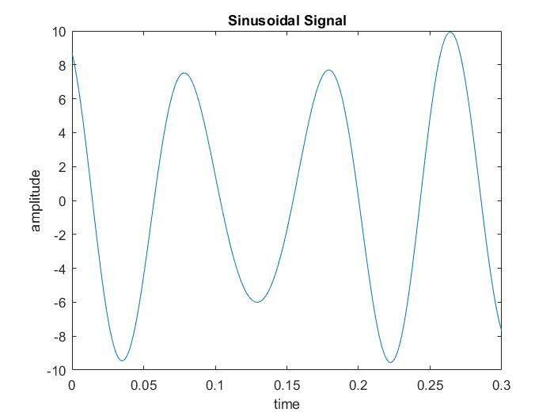

c) Subplot (3,1,1), subplot (3,1,2), and subplot (3,1,3) to make a three-panel subplot that puts all of three signals (x1(t), x2(t), and x3(t)) on the same window:

Code:

sampling_rate = 1000;

sampling_interval = 1/sampling_rate;

time_array = 0:sampling_interval:0.3;

sampling_rate = 1000;

sampling_interval = 1/sampling_rate;

time_array = 0:sampling_interval:0.3;

x1 = 2*cos(2*pi*(15)*time_array+27*pi/180);

subplot(3,1,1);

plot(time_array,x1);

xlabel('(time)');

ylabel('(amplitude)');

title('Sinusoidal Signal');

x2 = 8*cos(2*pi*(11)*time_array+30*pi/180);

subplot(3,1,2);

plot(time_array,x2);

xlabel('(time)');

ylabel('(amplitude)');

title('Sinusoidal Signal');

x1 = 2*cos(2*pi*(15)*time_array+27*pi/180);

x2 = 8*cos(2*pi*(11)*time_array+30*pi/180);

x3 = x1 + x2;

subplot(3,1,3);

plot(time_array,x3);

xlabel('(time)');

ylabel('(amplitude)');

title('Sinusoidal Signal');

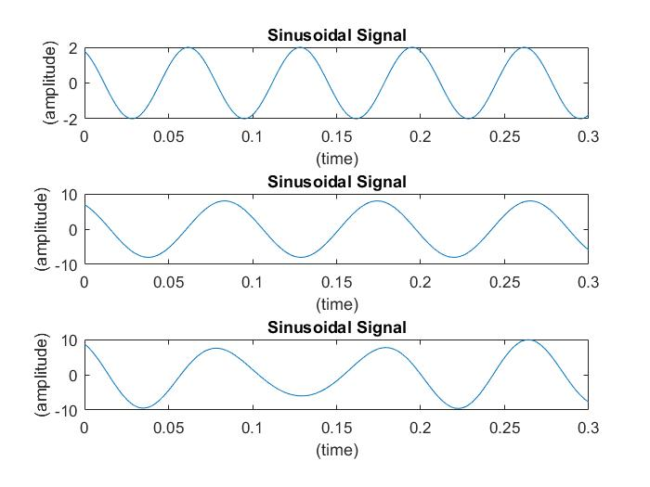

Discussion:

There is some of the bugs concluded with the definite organizational complementation with the functions of the MATLAB. The regression of the functions originated from the libraries inclines the comprehensive objective of this complementation. I face some problems while creating the plot and also face problems while calculation using my student id number. MATLAB takes some time while I try to run because my laptop configuration is low.